Book

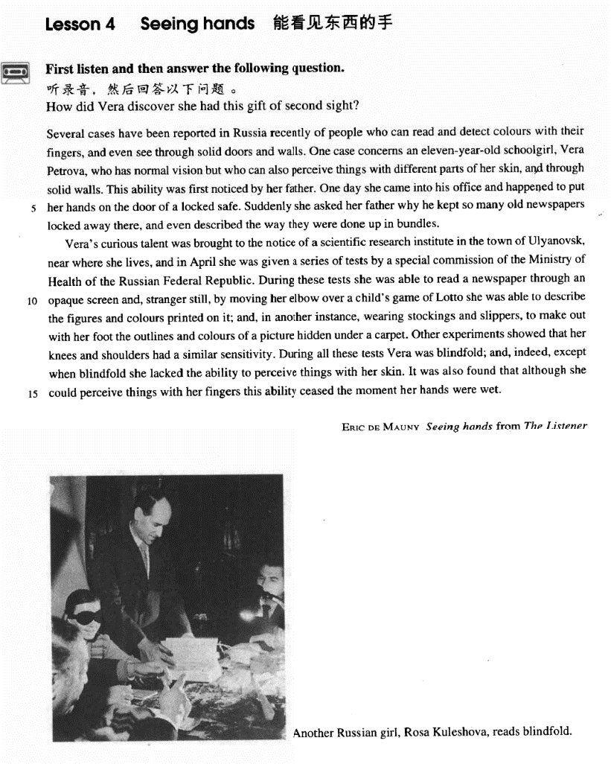

课文

Several cases have been reported in Russia recently of people who can read and detect colours with their fingers, and even see through solid doors and walls.

俄罗斯最近报导了几个事例，有人能用手指看书识字和辨认颜色，甚至能透过厚实的门和墙看到东西。

One case concerns an eleven-year-old schoolgirl Vera Petrova,

其中有一例谈到有一个名叫维拉.彼托洛娃的11岁学生。

who has normal vision but who can also perceive things with different parts of her skin, and through solid walls.

她的视力与常人一样，但她还能用皮肤的不同部位辨认东西，甚至看穿坚实的墙壁。

This ability was first noticed by her father.

是她父亲首先发现她这一功能的。

One day she came into his office and happened to put her hands on the door of a locked safe.

一天，维拉走进父亲的办公室，偶然把手放在一个锁着的保险柜的门上，

Suddenly she asked her father why he kept so many old newspapers locked away there, and even described the way they were done up in bundles.

她突然问父亲为什么把这么多的旧报纸锁在柜子里，还说了报纸捆扎的情况。

Vera's curious talent was brought to the notice of a scientific research institute in the town of Ulyanovsk, near where she lives,

维拉的特异功能引起了她家附近乌里扬诺夫斯克城一个科研单位的注意。

and in April she was given a series of tests by a special commission of the Ministry of Health of the Russian Federal Republic.

4月里，俄罗斯卫生部一个特别委员会对她进行了一系列的测试。

During these tests she was able to read a newspaper through an opaque screen and, stranger still, by moving her elbow over a child's game of Lotto she was able to describe the figures and colours printed on it;

在这些测试中，她能隔着不透明的屏幕读报纸。更为奇怪的是，她把肘部在儿童玩的“罗托”纸牌上移动一下，便能说出印在纸牌上的数字和颜色。

and, in another instance, wearing stockings and slippers, to make out with her foot the outlines and colours of a picture hidden under a carpet.

还有一次，她穿着长筒袜子和拖鞋，能用脚步识别出藏在地毯下面的一幅画的轮廓和颜色。

Other experiments showed that her knees and shoulders had a similar sensitivity.

其他实验表明，她的膝盖和双肩有类似的感觉能力，

During all these tests Vera was blindfold; and indeed, except when blindfold she lacked the ability to perceive things with her skin.

在所有这些实验中，维拉的双眼都是蒙着的。如果不蒙上双眼她的皮肤就不再具有识别物体的能力。

It was also found that although she could perceive things with her fingers this ability ceased the moment her hands were wet.

这是千真万确的。同时还发现，尽管她能用手指识别东西，但她的手一旦弄湿，这种功能便会立即消失。

词汇讲解

Lesson 4 Seeing hands

solid ['sɒlɪd]

adj. 结实的；实心的；立体的

solid adj. 1. firm; hard; strong solid doors and walls

The villa has solid foundations. flimsy

a flimsy table

a flimsy excuse

solid adj. 2. with no holes inside a solid ball

hollow

solid adj. 3. three-dimensional solid geometry

solidarity

Solidarity means strength / victory. safeguard national unity and ethnic solidarity consolidate

consolidate and strengthen the bilateral relationship commission [kə'mɪʃn]

n. 委员会

9/11 commission

National Development and Reform Commission committee

the Standing Committee of the National People’s Congress council

the State Council

the United Nations Security Council opaque [əʊ'peɪk]

adj. 不透明的

an opaque glass door

God’s reasons, if He has any, are opaque to us. transparent

translucent

blindfold ['blaɪndfəʊld]

adj. & adv. 被蒙住眼睛的（地）

I can do that blindfold. twofold / fourfold / tenfold

a tenfold increase

Business has increased tenfold.

We have to ask ourselves very seriously what will happen if this twofold use of knowledge, with its ever-increasing power, continues.

Hands that can see things

Several cases have been reported in Russia recently of people *who can*

*read and detect colors with their fingers, and even see through solid*

*doors and walls*.

We can read of things that happened 5,000 years ago *in the Near East*, *where people first learn to write*.

He maybe conceited, ill-mannered, presumptuous or fatuous, but I do not turn *for protection* to dreary clichés *about respect of elders*—as if mere age were a reason for respect.

If we glimpse the unutterable, it is unwise to try to utter it, nor should we seek to invest *with significance* that *which we cannot grasp*.

What is an intellectual? I shall define him as an individual who has elected *as his primary duty and pleasure in life* the activity of thinking in

Socratic way about moral problems.

His function is analogous to that of a judge, who must accept the obligation of revealing *in as obvious a manner as possible* the course of reasoning *which led him to his decision*.

As a logical consequence of this development, separate journals *have now*

*appeared* aimed mainly towards either professional or amateur readership.

We hold these truths *to be self-evident*, that all men are created equal, that

they are endowed by the Creator with certain unalienable rights, that

among these are life, liberty, and the pursuit of happiness. detect v. perceive; discern

I detected a hint of irony in her words.

… but who can also perceive things with different parts of her skin, …

In the breaking and remaking, in the timing, interweaving, beginning afresh, the writer comes to discern things in his material which were not consciously in his mind when he began.

He is too young to be able to between right and wrong.

[A] discard [B] discern

[C] disperse [D] disregard see through

Beijing administration has seen through pan-blues’ tricks. see sb. through sth.

Her courage and perseverance saw her through the hard times. see sth. through

The English course is very hard to learn, but I’m determined to see it through.

She promised to stand by him, and once you make that commitment you have to see it through.

The English course is very hard to learn, but I’m determined to see it through. get it over with.

They'll have to get some more paint.

They should get someone to help them.

They shouldn't delay any longer.

They don't have to paint the room again.

W: I honestly don't want to paint the room this weekend, Joe. M: Neither do I, but I think we should get it over with.

Q: What does Joe suggest?

Answer: (C) They shouldn't delay any longer.

The English course is very hard to learn, but I’m determined to see it through. get it over with.

stick it out.

Rachel: Oh God, I hate my job, I hate it, I hate my job, I hate it. Monica: I know honey, I'm sorry.

Rachel: Oh, I wanna quit, but then I think I should stick it out.

English Chinese

最近在俄罗斯报道了几个事例, 有人能用手指读书和辨认颜色, 甚至能够看穿厚实的门和墙壁。

One case concerns an eleven-year-old schoolgirl, Vera Petrova, who has normal vision but who can also perceive things with different parts of her skin, and through solid walls.

concern v. be about sb. or sth.

A recent case concerns Jane Butlin whose fiancé, John, runs a successful furniture business.

造句：最近一则新闻是有关于罗京，中央电视台的一位著名播音员

(newscaster)，因癌症而去世。

A recent piece of news concerns Luo Jing, a popular CCTV newscaster, who died of cancer.

be concerned with …

a book concerning music

a book concerned with music have normal vision

have good / perfect / 20-20 vision have bad / poor / defective vision near-sighted / short-sighted

far-sighted / long-sighted

ophthalmologist optometrist / optician

happen to do

it happen that …

I happened to meet an old friend in town.

It happened that I met an old friend in town. chance to do

it chance that …

I chanced to meet an old friend in town.

It chanced that I met an old friend in town. as it happen

As it happened, I met an old friend in town.

He would like to know what happened.

He can help the woman.

Because of what happened, he has no time.

He would have helped if he had the time.

W: I don’t imagine you would have time to help me with this. M: As it happens, I would.

Q: What does the man mean? Answer: (B) He can help the woman. by accident

by chance accidentally

I met an old friend in town by accident / by chance / accidentally. as luck would have it

As luck would have it, I met an old friend in town. W: You do look cold. What happened?

M: I've been standing outside in Arctic temperature for over an hour waiting for a bus.

W: Over an hour, but I thought your apartment was only a ten-minute bus ride to campus.

M:Under normal conditions, but the bus was delayed because of the weather and when I stepped into a drugstore to call home for a ride, the bus went by. As luck would have it, there was no one at home, so I had to wait another forty five minutes for the next bus.

W: That's Murphy's law, isn't it. What was it said "If anything can go

wrong, it will.” Well, we still get twenty minutes to gather our wits together.

W:You do look cold. What happened?

M:I've been standing outside in Arctic temperature for over an hour waiting for a bus.

W:Over an hour, but I thought your apartment was only a ten-minute bus ride to campus.

M:Under normal conditions, but the bus was delayed because of the weather and when I stepped into a drugstore to call home for a ride, the bus went by. As luck would have it, there was no one at home, so I had to wait another forty five minutes for the next bus.

W:That's Murphy's law, isn't it. What was it said "If anything can go wrong, it will.” Well, we still get twenty minutes to gather our wits together.

Suddenly she asked her father why he kept so many old newspapers locked away there, and even described the way *they were done up in bundles*.

lock sth. away / up

He locked his money away / up in the safe.

*the way*

in which

that they were ……

/

The conditions of society are such that skills have to be paid for in the same way that goods are paid for at a shop.

John Dewey has said in all seriousness that the part played by custom in shaping the behaviour of the individual, as against any way in which he can affect traditional custom, is as the proportion of the total vocabulary of his mother tongue against those words of his own baby talk that are taken up into the vernacular of his family.

One of the strengths of this essay is the way in which it thoughtfully considers the opposing claim: that great thinkers are primarily the product of fine education, and that, being "well schooled in the classics," they are far removed from everyday life.

*the time*

when at which

that

／

*the day*

when on which

that

／

do … up = fasten …

He stopped to do up his shoe lace.

All the packages are done up and ready for the post. Lions often hunt in pairs.

People began to arrive in twos and threes.

Vera's curious talent was brought to the notice of a scientific research institute in the town of Ulyanovsk, near where she lives, and in April she was given a series of tests by a special commission of the Ministry of Health of the Russian Federal Republic.

be brought to sb.’s notice / attention

Their working conditions were only brought to public notice / attention

last year.

come to sb.’s notice / attention

Vera’s curious talent came to the notice / attention of a scientific research institute in the town of Ulyanovsk.

From this the captain was able to piece together all the information that had come to light.

come to light / be brought to light

New evidence in this case has recently come to light.

has recently been brought to light. give sb. a test

a series of

a series of lectures / rainy days / math books

a train / chain / string / stream / succession / progression of

the Ministry / Department of Health / Education / Commerce / Finance

*During these tests* she was able to read a newspaper *through an opaque*

*screen* and, *stranger still*, by moving her elbow over a child's game of Lotto she was able to describe the figures and colours *printed on it*; and, *in another instance*, wearing stockings and slippers, to make out *with her*

*foot* the outlines and colours of a picture *hidden under a carpet*. stranger still

better still worse still harder still

The medical expenses are a massive drain. Worse still, Greg may lose his job.

to make matters / things worse let alone …

not to mention …

The baby can’t talk, let alone run.

He can’t run a hundred yards, let alone a mile.

I don’t suspect him of theft, let alone of robbery. They own two houses, not to mention a yacht.

The dampness is unpleasant, not to mention the cold.

In short, without better evidence that the survey is statistically reliable the chairperson cannot rely on it to draw any firm conclusion *about the*

*overall recycling commitment of West Egg residents*—let alone *about how*

*quickly the landfill will reach capacity*.

Moreover, the author has not shown *any correlation*, let alone *a*

*cause-and-effect relationship*, between the number of hours a person spends watching television and that industry's profits.

Without ruling out all other possible explanations for the grade-average increase, the dean cannot convince me that by terminating the evaluation procedure Omega would *curb its perceived grade inflation*, let alone *help*

*its graduates get jobs*.

In short, without ruling out other possible reasons for the strong sales the vice president cannot convince me *that Plainsville residents are*

*exercising regularly*, let alone *that they would be interested in buying the*

*sorts of food and other products that NW sells*.

… she was able to make out with her foot the outlines and colors of a picture hidden under a carpet.

In 1975, the number of students in our school was about five hundred, and in 1981, over two thousand.

In 1975, the number of students in our school was about five hundred, and in 1981, the number of students in our school was over two thousand. make out: see or hear sb. or sth. with difficulty

I could just make out a figure in the darkness. I couldn’t make out what he was saying.

… except when (she was) blindfold she lacked the ability to perceive things with her skin.

Metals expand when heated and contract when cooled.

Metals expand when they are heated and contract when cooled.

Metals expand when they are heated and contract when they are cooled. Francis Preston Blair Jr., although born in Kentucky, lived and practiced in Missouri.

Francis Preston Blair Jr., although he was born in Kentucky, lived and practiced in Missouri.

We’ll resolve the Taiwan issue with peaceful means when ever possible, with force when necessary.

We’ll resolve the Taiwan issue with peaceful means when it is ever

possible, with force when necessary.

We’ll resolve the Taiwan issue with peaceful means when it is ever possible, with force when it is necessary.

It was also found that although she could perceive things with her fingers

this ability ceased *the moment her hands were wet.*

cease to do cease doing

There are instances when patriotism ceases to be an empty slogan. stop to do stop doing

Stop to smell the flowers.

I’m exhausted. Let’s stop to smoke.

Please stop smoking. Smoke really bothers me.

… *the moment*

at which when that

/

wet a wet sponge

moist & damp

Bring me a moist towel. a cold, damp collar

humid humid atmosphere

humid summer nights